Annotating contrast CT scans
Sep 28, 2026 · @Sanyog Vyawahare

Before you start
A contrast scan has no fixed calcium threshold. The 130 HU used for non-contrast CT is useless on it. So the first step it to compute a scan-specific threshold for annotation. We do this by placing a seed point in the ascending aorta (On the same slice where you see the left Ostia) and in the backend we compute a 200mm3 volume and compute Mean and standard deviation and our scan specific threshold is as below.
The threshold it derives is:
threshold = μ + k σ
μ and σ are the mean and standard deviation of the HU values inside the sampled sphere. k is the K multiplier box, default 3. The sphere grows outward from your seed until it reaches the target volume box, default 200 mm³ — so those two boxes are the only inputs, and the scan supplies the rest.
Two things to know:
- You cannot paint until the seed is finalized.
- Set Save folder once, in Settings. Everything you annotate goes there.
  - The app will create a directory called "Manual_Annotations"
  - If the directory "Manual_Annotations" is already present the app will select that folder automatically.

Flow 1 — one DICOM folder
Use this when you have a folder with DICOM series.
1. Paste or browse the folder path into CT file path (or use Browse DICOM dir), then click Load CT.
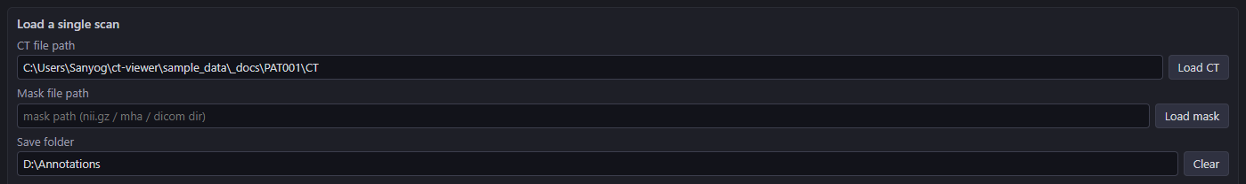
You can iterate using the Previous / Next series buttons on the top of the image.
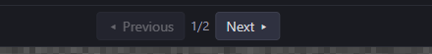
2. To start annotation -> Turn on Contrast CT.
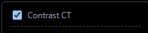
3. Place the seed. Tick Set AO seed, then click near the left ostium, centre of the ascending aorta. The dotted circle is the sphere that will be sampled — click again to move it.
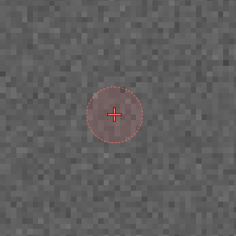
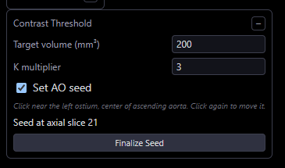
4. Click Finalize Seed. The threshold appears and locks for this scan. Leave the target volume and K multiplier alone unless you have been told otherwise.
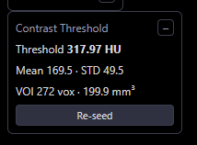
Got the wrong spot? Re-seed clears it and lets you place another.
5. Annotate. Click + New mask to edit, pick a label, then left-drag on the image. HU ≥ is already set to your threshold and cannot be edited.
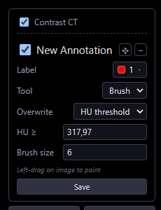
Tool is how you paint:
Option | How to? | What it does
Brush | Left-drag to paint. Ctrl+drag rubs out. | Let's you refine the boundaries of your annotation
RG (region grow) | Right click to set a seed for 3D lesion detection.  Shift+ right click convert the cursor into a circle for tiny lesion  Shift+scroll resizes that circle. | Based on the seed automatically finds all voxels above the set threshold part of the selected lesion.

Overwrite appears for Brush only, and decides which voxels the brush may change:
Option | What it does
HU threshold | Only voxels at or above HU ≥
Any voxel | Everything under the brush.
Existing label | Overwrite only existing labels not the background

Two buttons under the box: ⌫ Erase mode sets the label to Background so the next stroke rubs out, and ⟲ Reset puts the mask back to the last saved state.
6. Save. The tag above the image tells you what you are looking at and when it was last saved.

Flow 2 — a manifest spreadsheet aka excel
Use this to work through a list of cases annotating is identical to Flow 1. This is useful when you want to make notes alongside your annotation or tag a scan to be reviewed later by an expert.
1. Point at the sheet. Open Settings › Batch Load, paste or browse the path to the Manifest file, check the column names below to match your sheet, then click Load manifest. The first case loads on its own.
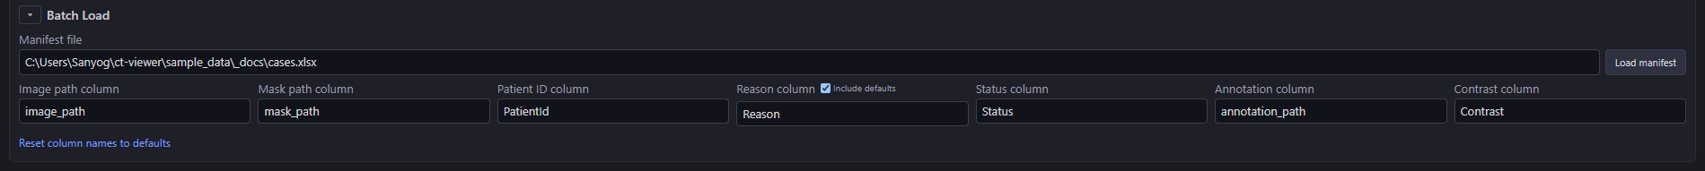
The column boxes are names, not data — set each to the column in your sheet that holds that thing, or leave it as -- none -- if your sheet has no such column.
2. Annotate, exactly as in Flow 1: seed, finalize, paint, save.
3. Move on. Previous / Next step through the list; type a number in the box between them to jump straight to that case.
If you have unsaved changes, you are asked before the next case loads — you can save from that prompt.
TIP: One difference worth knowing: if your sheet has a Contrast column set to Yes, contrast mode turns itself on when the case opens. You do not have to remember the checkbox.

The manifest columns
Only the image column is required. The app creates the last four itself if they are missing.
Column | Holds | Required
Image path | Path to the DICOM folder or the .nii.gz / .mha file | Yes
Mask path | An existing prediction to start from | No
Patient ID | Shown in the corner; used to pair cases in split view | No
Reason | Tags for why a case was flagged | No
Status | Where the case is up to | No
Annotation path | Written by the app when you save | No
Contrast | Yes for a contrast scan | No

The app never writes over your mask path — your saved work goes in Annotation path, so the original prediction stays where it is.

Where your work goes
One folder per scan, inside your save folder:
<Save folder>/Manual_Annotations/<scan>/
annotation.nii.gz your labels
_source.json what this is, and when you saved it
contrast_seed.json the seed and threshold
<scan> is the DICOM series UID, or the file name for a .nii.gz. Pointing Save folder straight at an existing Manual_Annotations folder is fine.
When you open the same scan again, the app finds that folder on its own: your annotation loads instead of the original prediction, contrast mode switches on, and the threshold is recomputed and checked against the saved one. You do not re-place the seed.

